MINISTRY OF EDUCATION AND SCIENCE OF THE REPUBLIC OF KAZAKHSTAN

INTERNATIONAL INFORMATION TECHNOLOGY UNIVERSITY

FACULTY OF INFORMATION TECHNOLOGIES

Department of Computer engineering and information security

COURSE PROJECT

Educational program 6B06301 Computer security

Discipline Web technologies

Topic: Mounteam - SIMPLE MOOD FORMULAS

|  |  |  |
| --- | --- | --- |
| STUDENT(S): | ISCS-1902  Tokmurzin Mukagali  Tursynbay Aibolat  (group and student name) | Изображение выглядит как провод, линия  Автоматически созданное описание  _____________  (signature) |
| SUPERVISOR: | Assistant-professor  Mukazhanov N.K.  (position, name) | _____________  (signature) |

Almaty 2021

# **Content**

Introduction ….

Main part

1 Theoretical part

2 Design

3 Implementation (creation of website)

Conclusion …

References …

Appendix A …

# **Introduction**

About course project topic

We choose topic Mounteam, which organizes available tours for everyone. Motto of Mounteam, “SIMPLE MOOD FORMULAS ". Additional information about this project, it’s real and it’s my friend project, he created Mounteam last year in May, know he works with Instagram and arranges trips to beatyfull places like Charyn, Colsay lake, Butakovka, Gorod Kochevnicov, Issyk lake and other place near with Almaty. You can visit his instagram account:<https://www.instagram.com/mounteamkz/>.

Main feature is make trips easy and simplify the way of buying tickets for people and so, we have 7 pages, which listed below. Logic of our site is we have the page trips, where person can chose on of them and this trip into basket. For this, he need to Log in or Sign up and then log in. Then using data base the number of tickets for one of this trip will decrease. Also, system admin of site can add content and change design of web site.

Mounteam Inc. is an online travel agency owned by Mounteam Group, an Kazakh online travel shopping company based in Almaty. The website and mobile app can be used to book vacation packages and hotel reservations

Project relevance: Travel agents are still used for expert guidance, personalized travels, and to save time. The Internet has made it easier to book your own travels, but with that comes informational overload.The value of a travel agent is the ability to provide a personalized travel experience at the right quality and price and most importantly, saving time and energy for their customer.

1. Lists of my pages:

Main page

Trips page

Reviews page

Contacts page

Basket page

Sign in page

Sign up page

Main Page

The beauty of the site is that it is in the background, and on the first page. Because the first user will know what the first site looks like from the main page. In the background, we put the same image that is common to the entire surface. And the footer, as usual, will be the same for all surfaces.As you can see on the main page, you can learn about the train categories and about us.

Trips Page

The category of our trains consists of 3 parts. The visitor can easily select the desired ticket and put it in his basket. This page shows all the trains as you can see 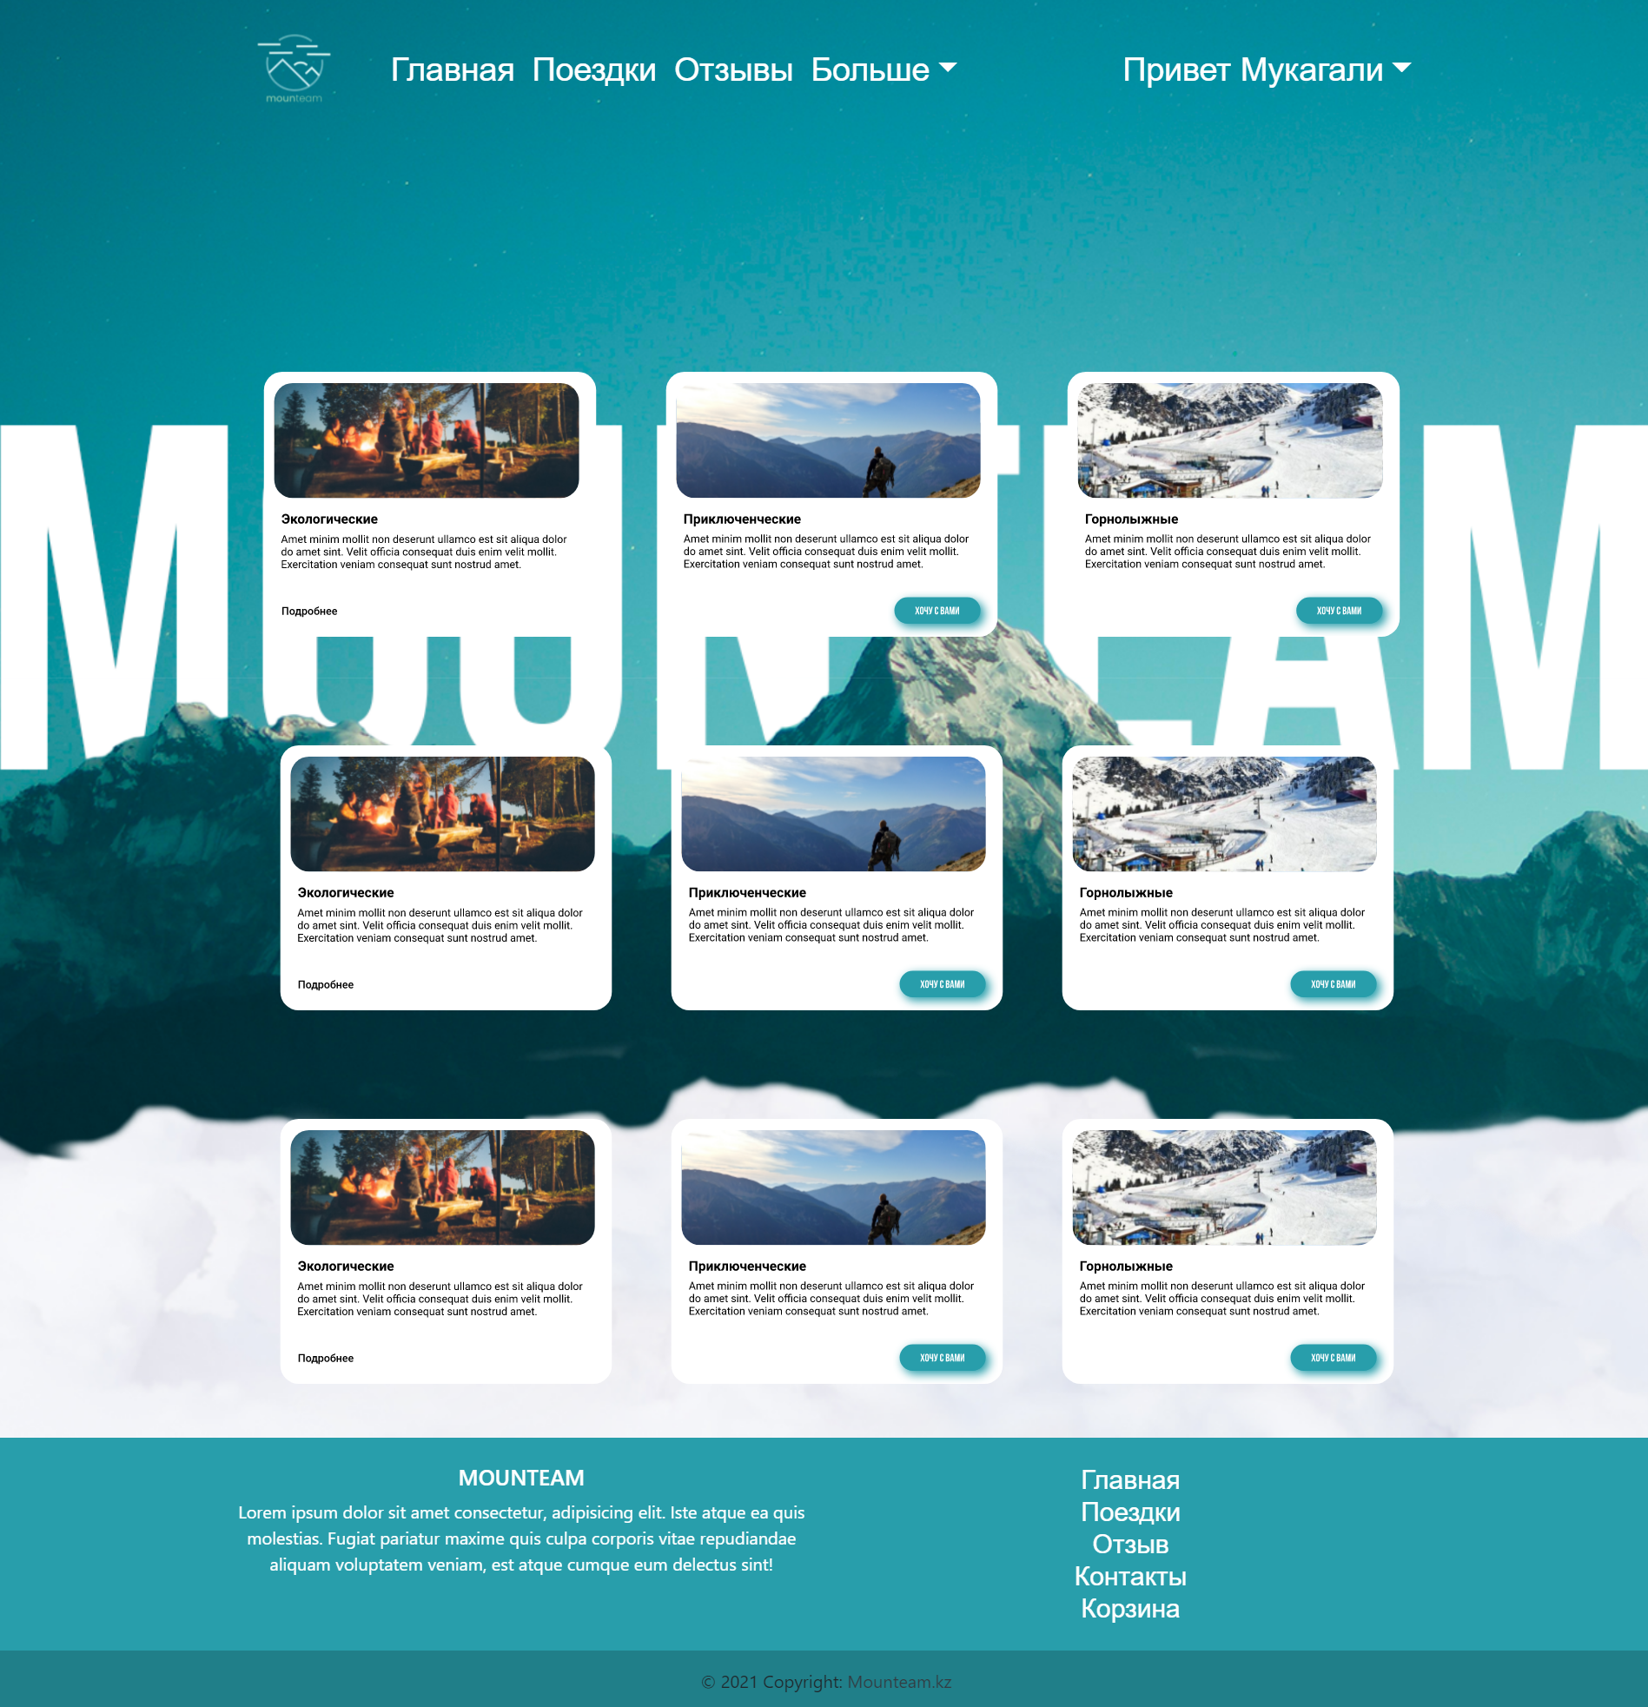

Reviews page

On this page, you can ask a direct question to the managers on our website. Ask a question by clicking the button. And before you ask a question, you can find answers to frequently asked questions. At the very top, you can read the reviews left by the people in front. Everything is clear and convenient. For us, the main thing is to create a simple website that is understandable to users.

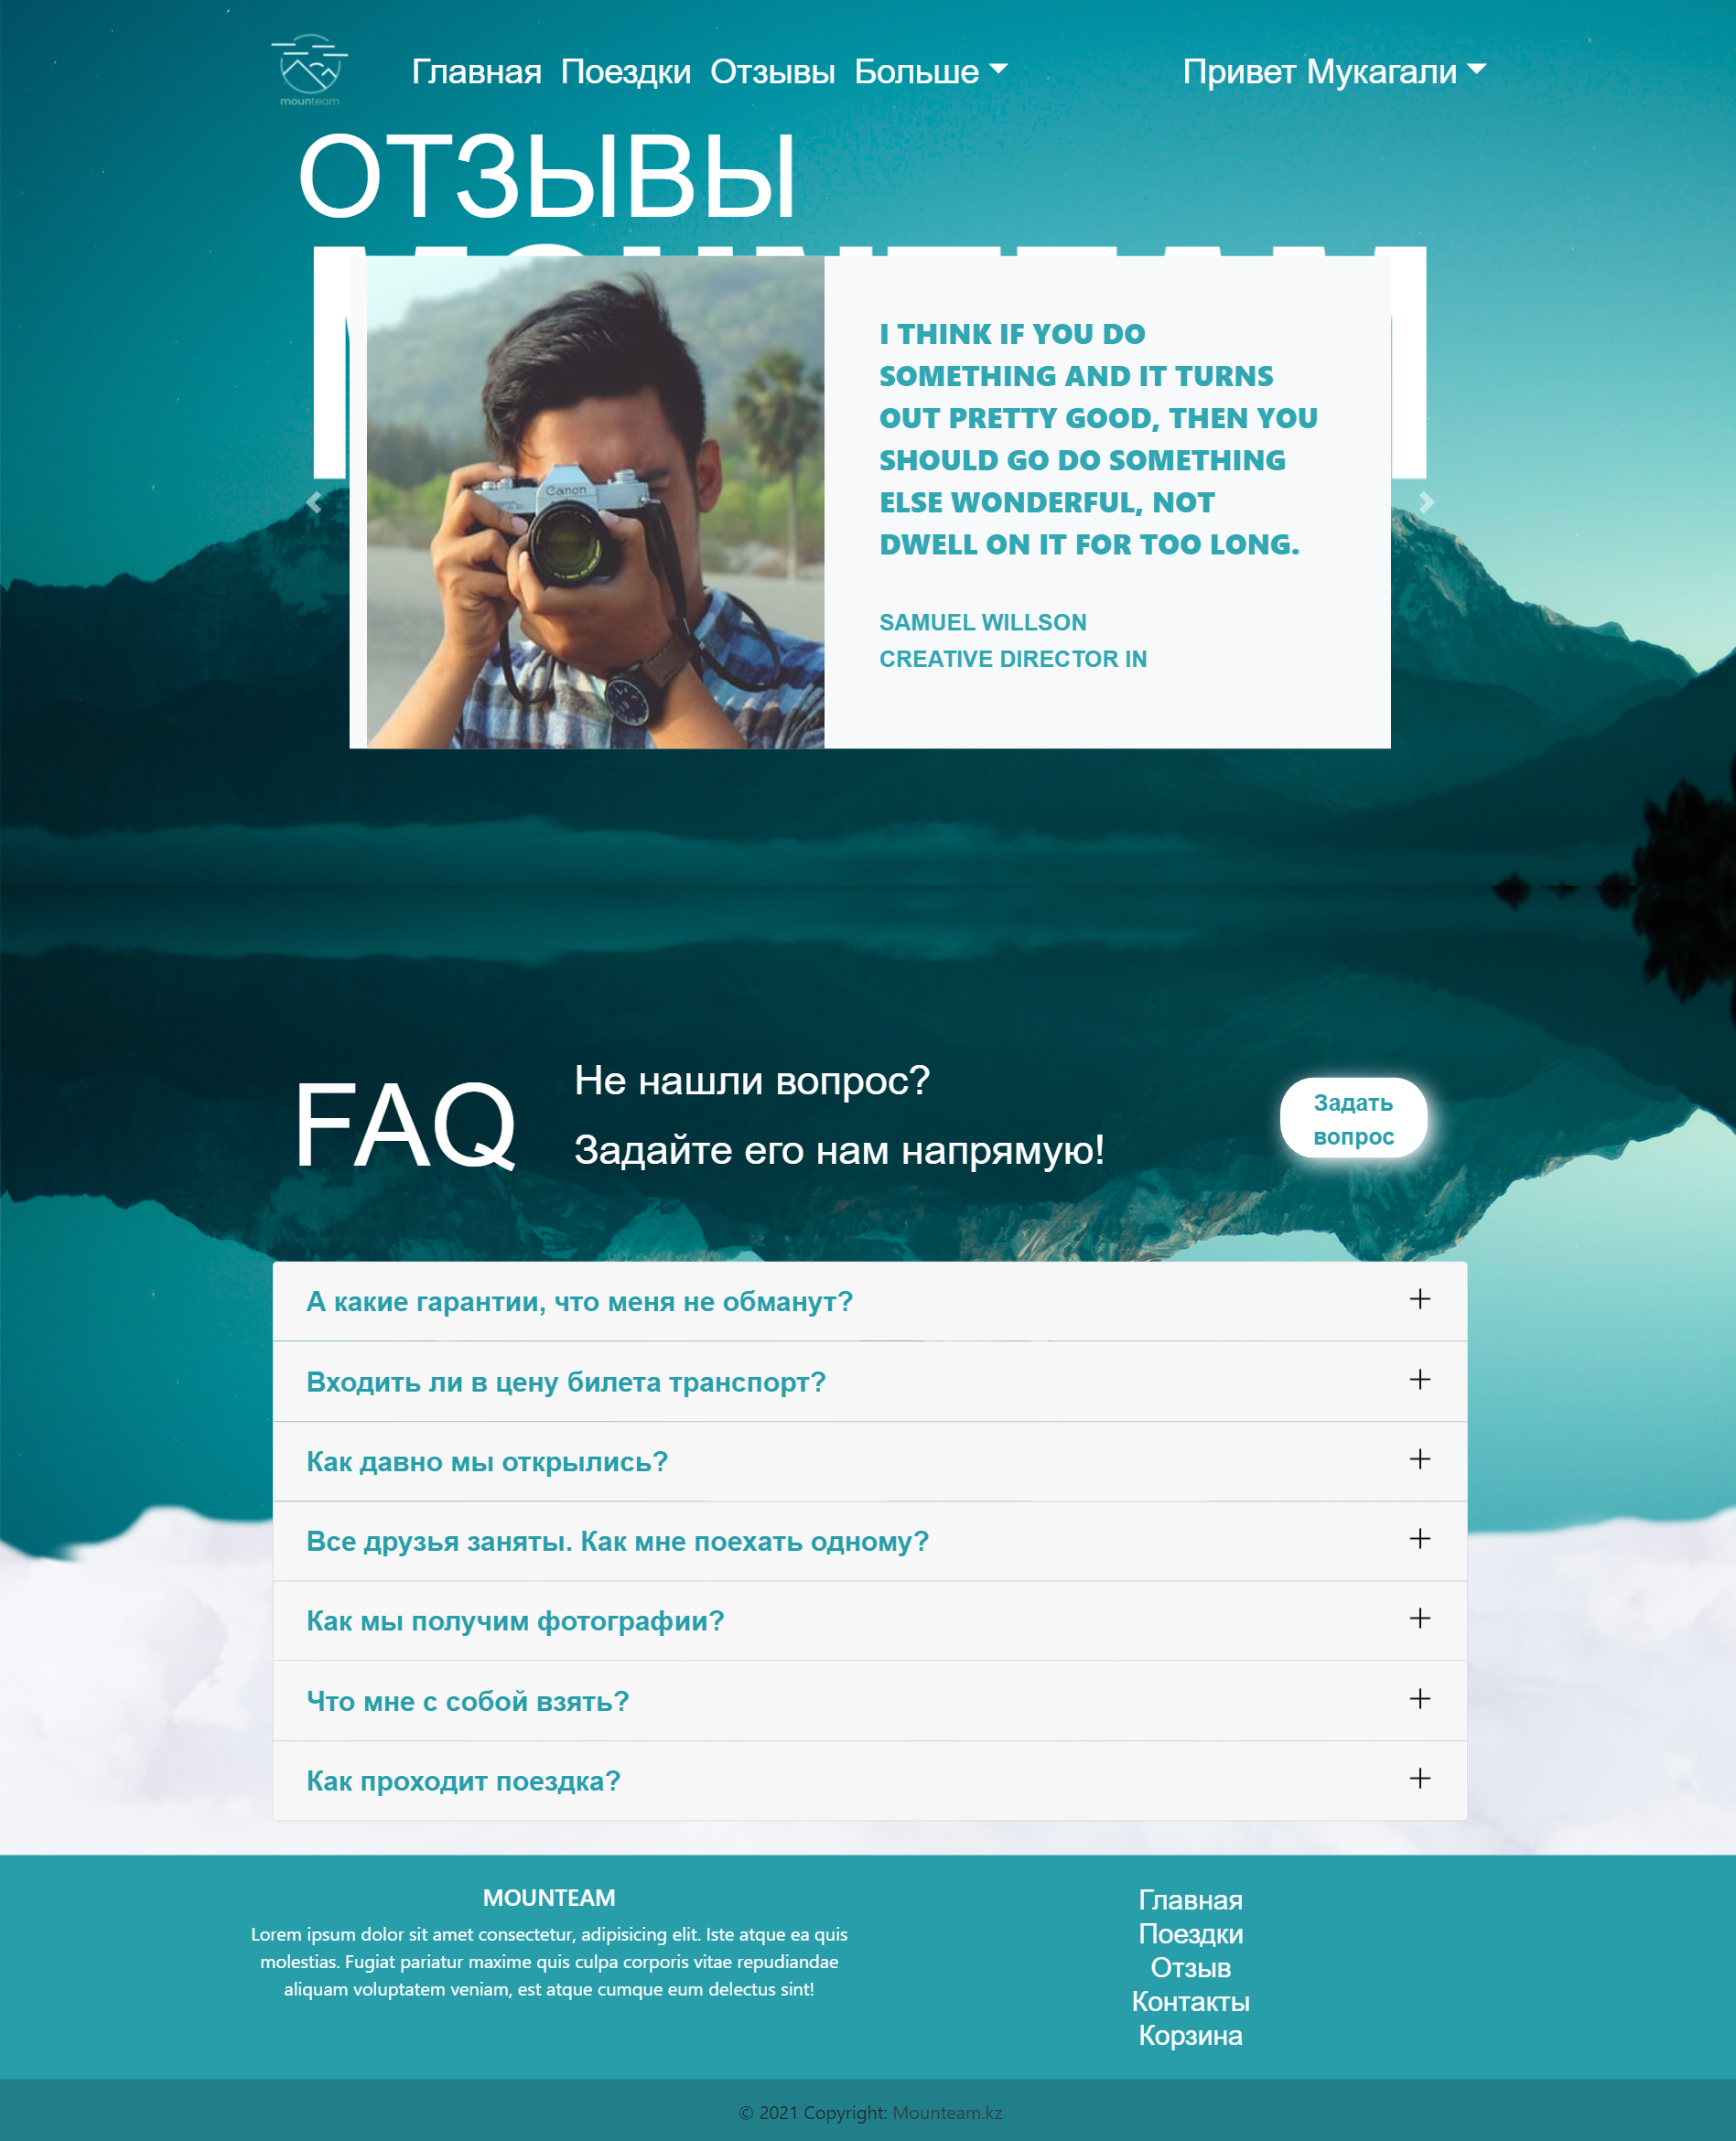Contact us Page

The reason we created this page is to make it easier to communicate with us. You can find out our address by contacting us with feedback. You can be the first to hear the message by connecting to our accounts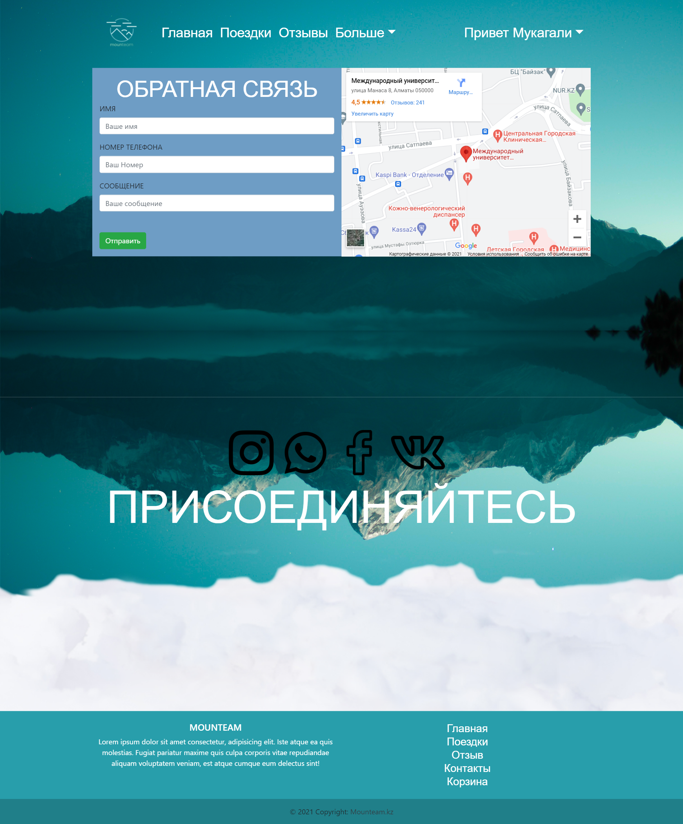

Bascket page

This page is designed to collect the tickets that we have selected and to ensure the purchase in a convenient way. You can buy a ticket directly by knowing the ticket information by the function of this page

About web site development

Aibolat and me created from scratch design of this web site and draw it firstly in Tilda.com and then write code with using HTML5, CSS and Bootstrap v4.6. Also, we make our site responsive, so our site will be elegant in any devise, accent is mobile phones, because more than half audience is using mobile phones. We arrange soulful trips to the beautiful places of our favorite city. Most of our audience is young people, so we have come up with fun entertainment programs and interesting excursions.

Our main issues were the drawing up of the website texture plan as well as the formation of the standard as well as the problems of the website with the application of HTML5, CSS and the Bootstrap framework. Then I worked with PHP and formed the basis of the information for the purpose of our plan.

The website will be formed from permanent pages, the firmware node will be written in the PHP programming style, and the MySQL database is also created according to the principle of reflecting the constant data. The website has every chance to be regulated by admins, for this reason, the admin socket will be invented in the website in order to manage the content of the following list of features:

Main part

1 Theoretical part

The task of this plan was to learn how to form adaptive standards as well as the problems of Internet websites with the use of interface devices, such as HTML5, CSS and Bootstrap CSS framework, also after this activity, I can say with full confidence that I have fully learned. I also used PHP, Mysql, AJAX, jQuery , Javascript for the purpose of our plan,

The composition of the Internet supplement

More in general, online add-ons are concluded equally with at least 3 key parts:

The subscriber share of the Internet add-on assumes a graphical socket. Given in this case, what you present in the page. The graphical socket is reflected in the browser. The subscriber interacts with the Internet add - on via the Internet browser, pressing the hyperlinks also with the keys.

The server share of the Internet add-on is a project or script in the server that cultivates the requirements of users (more specifically, the requirements of the browser).

More in general, the server share of the Internet add-on is programmed in PHP. Any one time, if the subscriber clicks on the link, the Internet browser sends the request to the computer. The computer cultivates this demand by initiating a certain PHP script, which creates an Internet page, depicted in HTML, and also sends it to the buyer according to the bond. The Internet browser immediately reflects the result in the version of another Internet page.

The basis of information (DB, or the concept of managing the basics of information, DBMS) - software provision in the server that stores information and enters it into the required period. In the case of a forum or blog, the information stored in the information base - the given information, the note, the announcements - is also thus followed. The basis of the information hosted in the server. Server share of the Internet add-on (polyadelfit. letter. PHP-script) is sent to the data base, extracting the information required for the purpose of developing the page requested by the user.

The Internet browser sends HTTP requests to the Internet computer via the Internet. The Internet computer generates a PHP script created by the developer of the Internet add-on.

The presence of a PHP-script need is routed to the information base. As a result, RNRscript gives the buyer an Internet page, which reflects the Internet browser .

Programming styles for research purposes

The main style used to display the graphical interface of an Internet add-on is HTML. This text represents the texture of the Internet page, the location of its parts.

The design of Internet pages, their image and color palette are depicted in the tables of manners-CSS.

There is no need to completely reload the page after any extraction of information from the server, you can significantly stimulate the Internet add-on service. This theory is called asynchronous JavaScript also XML (multi-time JavaScript also XML, Ajax). When using this layout, dynamic requirements to the server are made in the absence of a noticeable restart of the Internet page: the subscriber does not notice in any way if his Internet browser breaks the information .

The importance of the basis of information in the formation of Internet add-ons

In accordance with the traditional definition, the basis of information is an organized set of data stored in a variant of sets, any of which includes a general-view log.

Basic data management (DBMS) concepts give the software developer the most powerful tools for generating, updating, and processing large data sizes that have a complex texture.The favorite among the sources of information used for the purpose of researching Internet add-ons, today, undoubtedly, is considered MySQL. The main advantage of MySQL (regularly reported in time).:) its lightness is considered. As a result, the high rate of execution of SQL queries is also the need for obvious programming of key laws in order to strengthen the unity and consistency of information to the extent of server additions. From among other sources of information used for the purpose of Internet research, I also mark Oracle as PostgreSQL. PostgreSQL is an easily distributed DBMS with non-closed source code, directed to the main service in UNIX-like concepts.

creating a subscription share

In the framework of the dissertation, a graphical socket is shown for the purpose of Guest roles, Admin roles. About the guest there is a chance to get acquainted and also use the purpose of the basket. The manager has the ability to prepare for printing as well as eliminate the log in the tables7

1. Design

Database

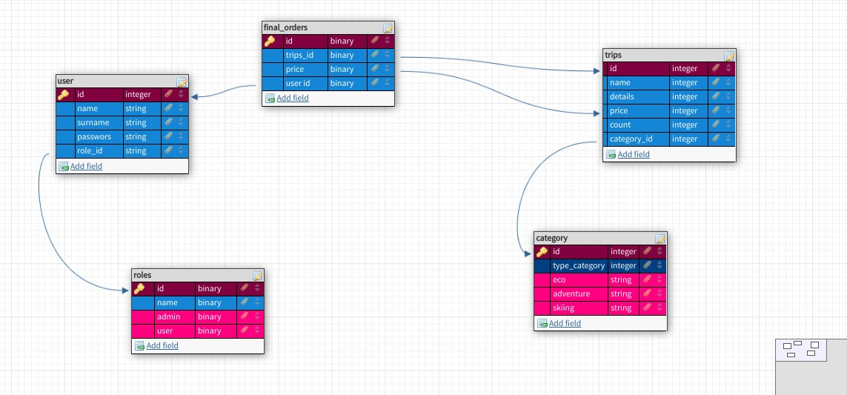

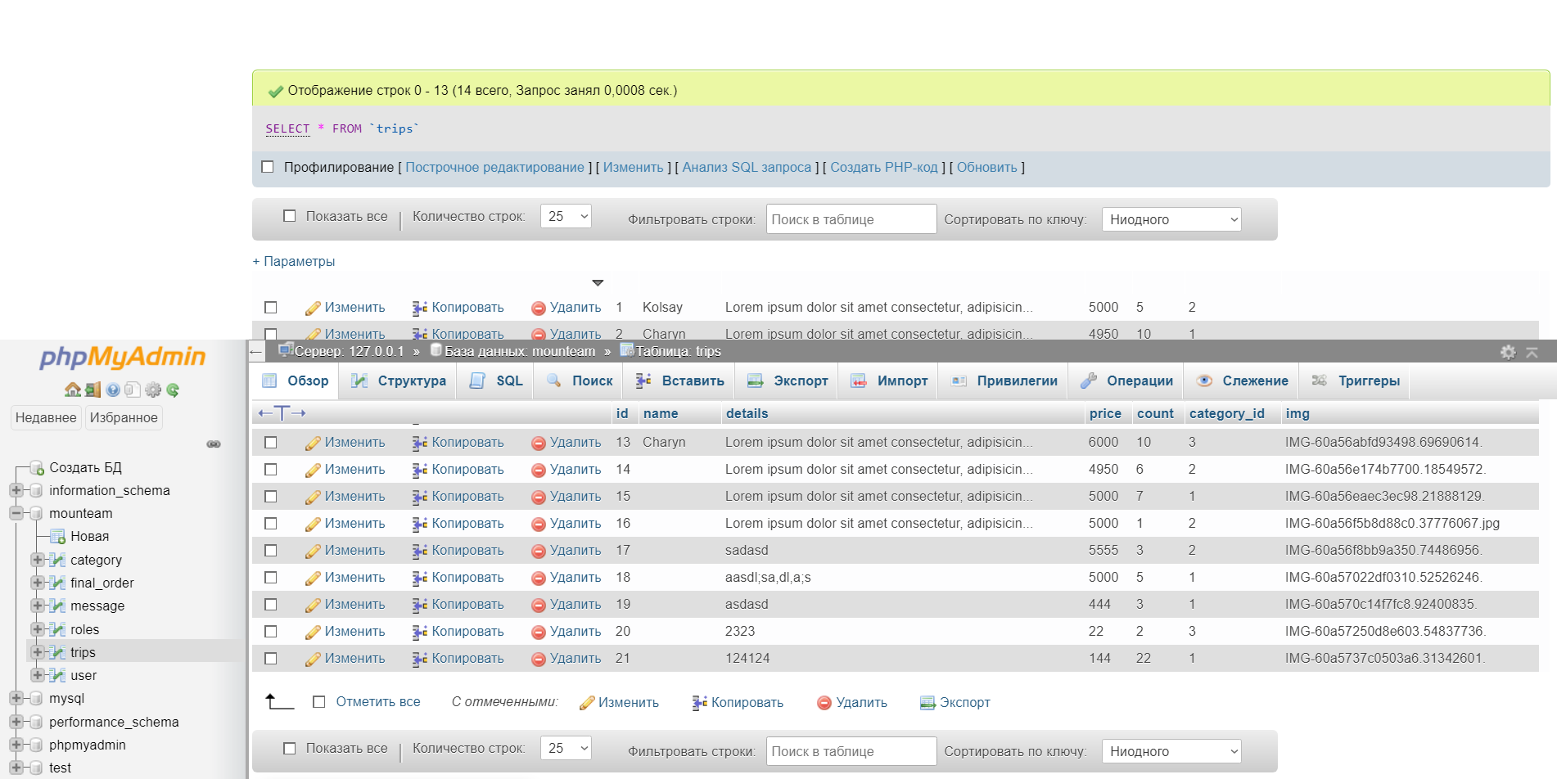

Web design

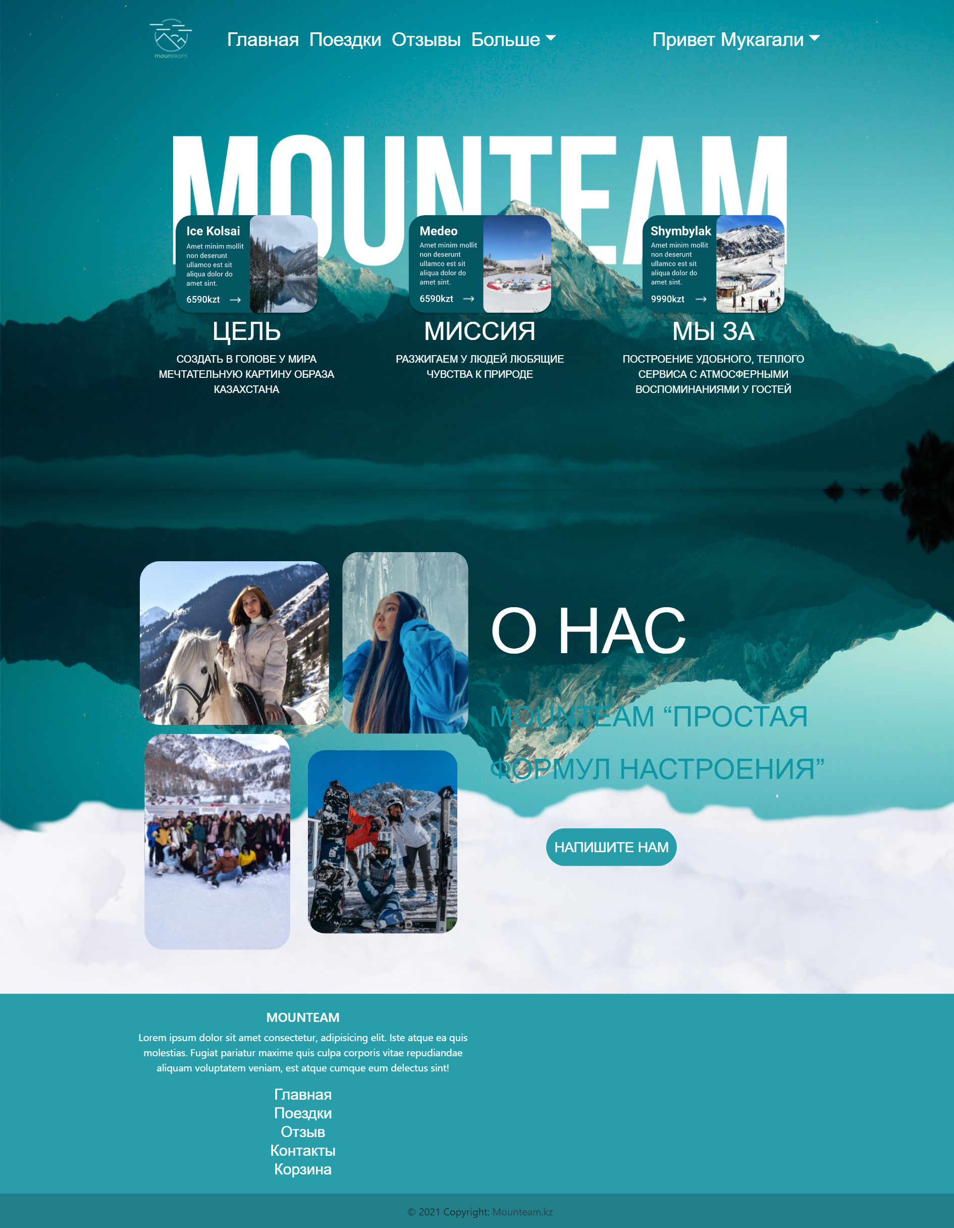

3 Implementation (creation of website)

*Next We want to start with describing main blocks of web site. They are NavBar menu and background image and footer part. We thing it would be more convenient for you.*

**So, let’s talk about bootstrap, I downloaded Bootstrap v 4.6 with JS, We used only file bootstrap.css and bootstrap.min.js files and connected them with my project. Also, We added my own css file main.css.**

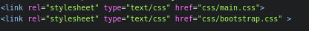

**Also added scrips and Java Scrips and Jquery**



**First of all nav bar, I wrote down nav-menu using Bootstrap and added my own css styles and result here. Main problem here is make nav bar menu responsible, in this case I search from official web site of Bootstrap and use class navbar-toggler button. Also, for links to other pages I used #a and ul/li. With power of Jquery and JavaScrtip it’s magically work. Next I added login button, it’s for registration or log in of user.**

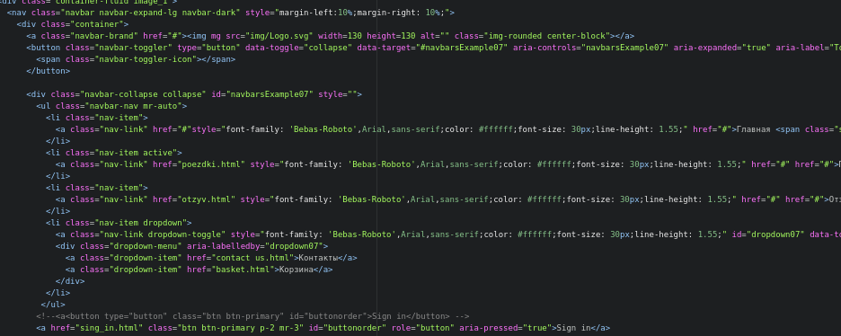

**Next, part we used 2 background images, it was quiet difficult. For this we used 2 container-fluid and give them 2 background images with using css code. With power of margin, We give him negative value and put cloud up the second page.And the result, how you can see.**

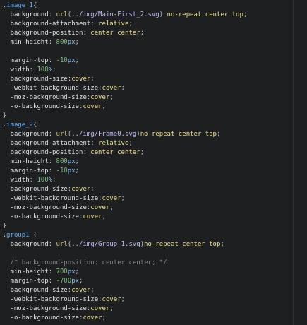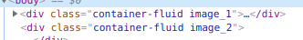



**And the last main part is Footer. Footer consist from 2 parts, Footer top and Footer-bottom**

**Footer top consist from 2 block, I separate them using rows and col. It consist some helpful info and 3 part is links for other pages.** **How you can see.**

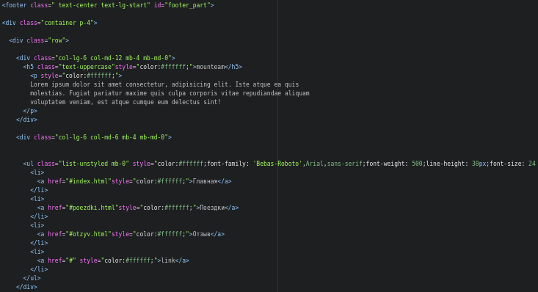**And footer-bottom is quiet simple, it consist from block copyright and how you can see.**

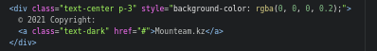



**5. Now we are going to stop for body content of every page. In all pages nav-bar and back-image, footer part is equal.**

**1. Main page(index)**

**Main page container with 3 container with photo and description, you can see them above. I used display-flex and justify-content for putting then into one line and add my styles.**

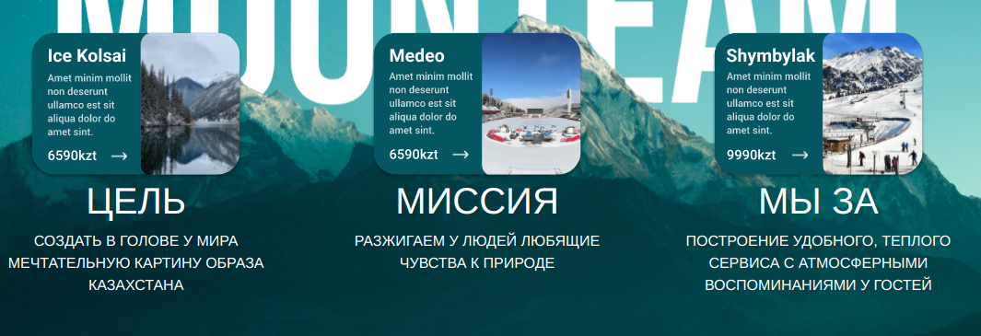

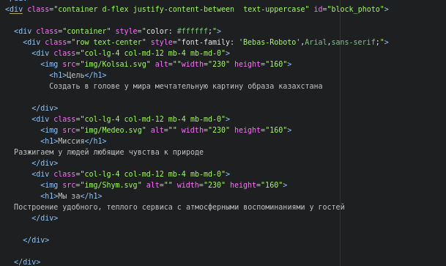

**This block consist from 4 image and some Heading. I give them fixed width, and to adaptiveness I used media queries and change display:block and change width.**



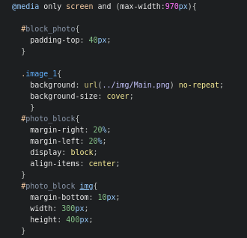

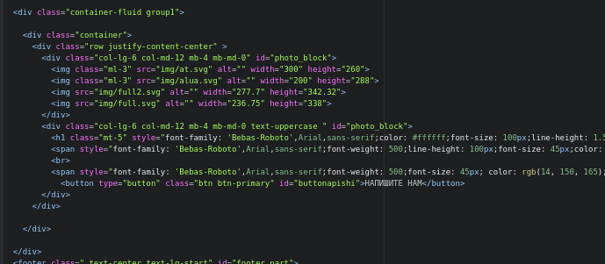

**2. Trip page. This page quiet simple, I think that it doesn’t need any description.**

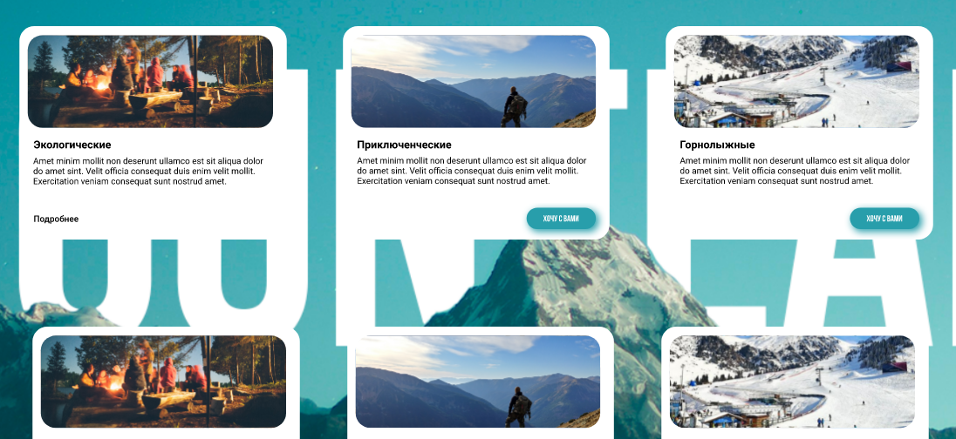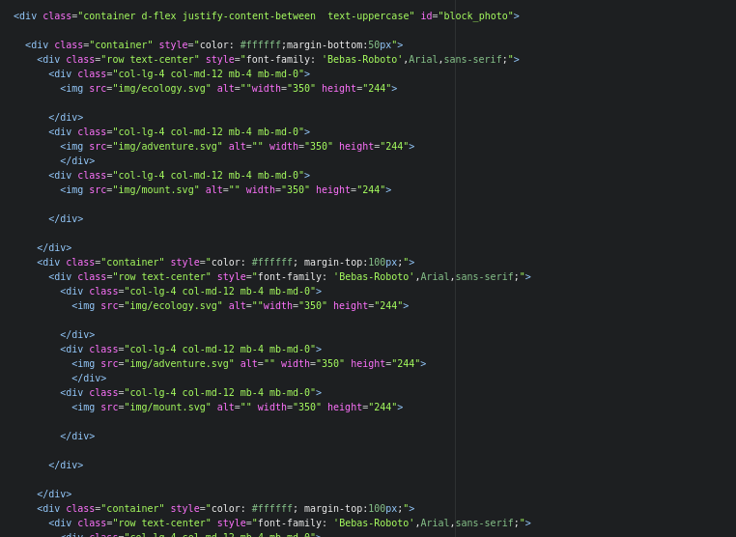

**3.*Reviews page – this page consist from 2 part: Carousel part, FAQ***

***There are might information about team member and founder, it would be helpful for users. There might be countless page.***

***There you can see code, I take template from official web site of Bootstrap and my own style, like font size and etc. I also use d-flex and justify-content-bettween for putting two blocks, how you can see. And make adoptive with media queries, you can see them in file main.css at the end of file.***

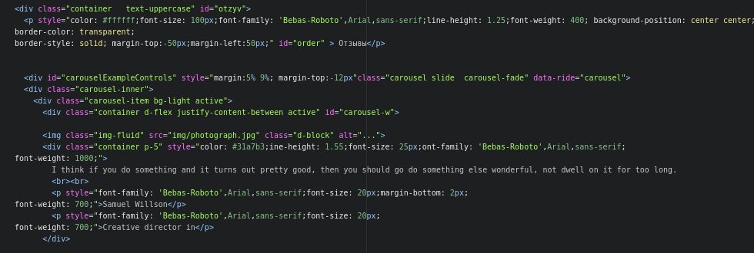

**Next is FAQ part, there some questions and when you click it unfolds, how you can see, it works thanks to JavaScrips with collapse of bootstrap and Jquerry.**

**There you can see code, we also take template from site of Bootstrap**

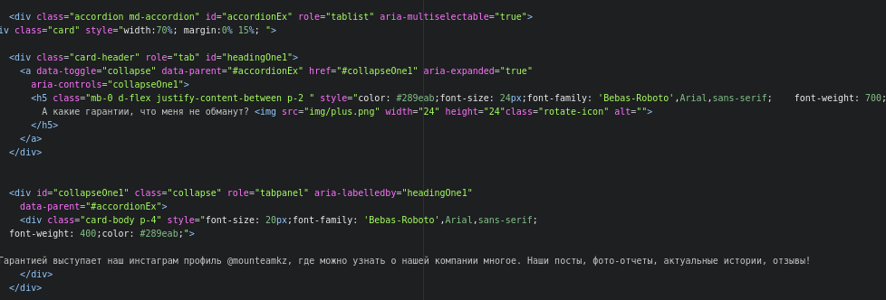

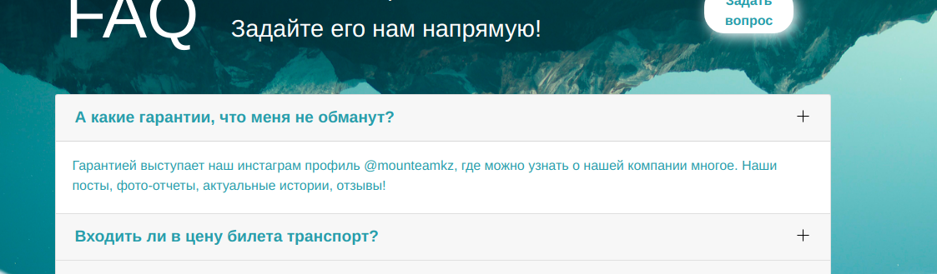

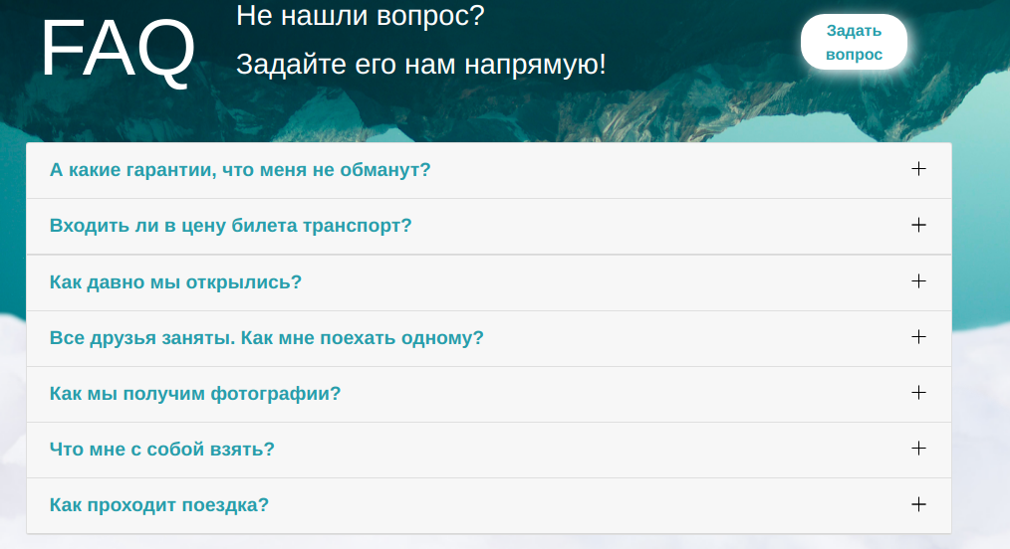

**4.*Contacts page - the structure of this page is also simple, it consist from one block, there are form with contacts, also there are maps, location of the office.***

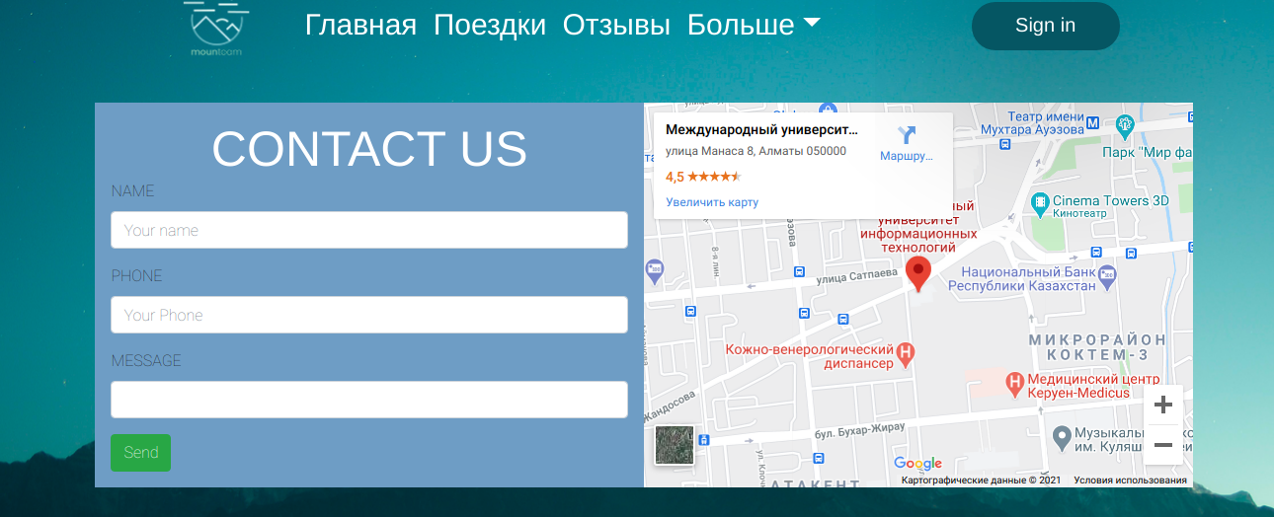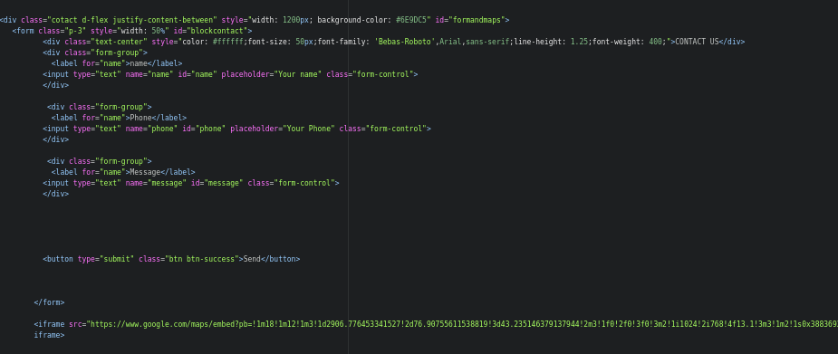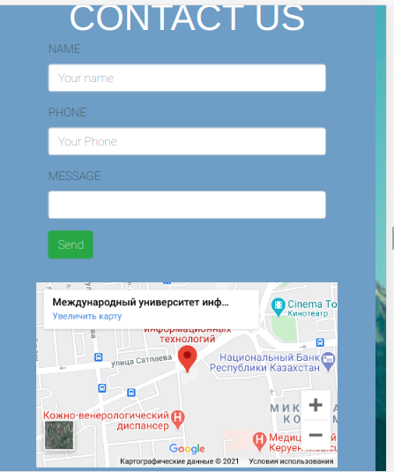**It’s also has a elegant design and fully adoptive for all screens.**

**Also, there are links for instagram, whatsapp and facebook**

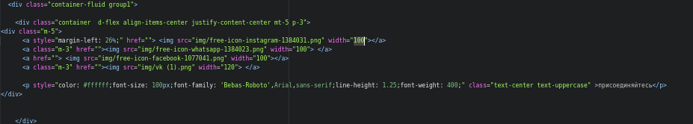

**5. Basket page, main feature is adding trips and buy them using payment systems. So, with using php and data base, it will work. Now it’s just model. Also it’s elegant and simple design. We also take l template from official site Bootstrap and add our styles and content. It doesn’t have some difficult code, so I think it’s enough**

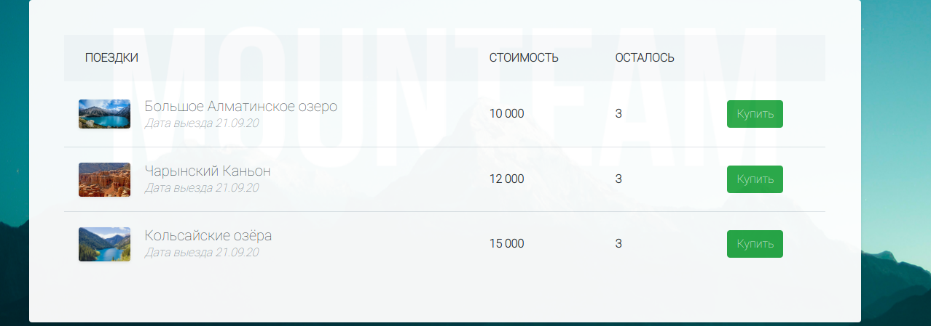

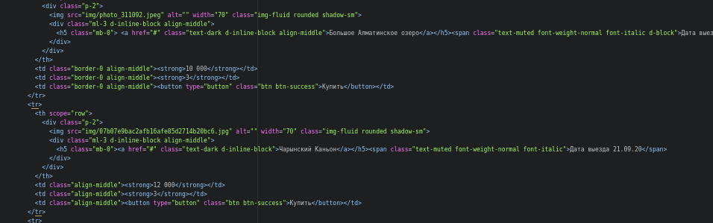

**6. Sing in page – is one of beautiful pages and elegant design. Using this page you can log to your account and continue buying process. They are made by using simple forms with input.**

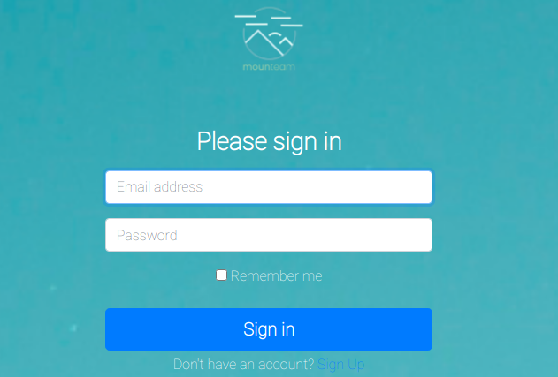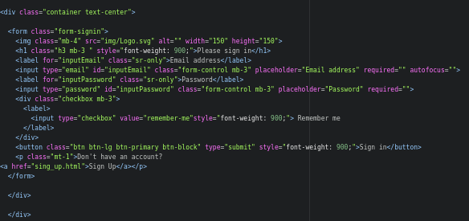

**7. Sign up page – if you do not have account, you can create it with this page and then log from sign in page. You need to enter your name, Sure name, email and password. It made by using simple input layouts and with adding my styles.**

**As you can see, the connection of our web application with the database. we needed to specify the information table of our application, link it to the database and change this information, that is, add a new table, or delete and add it.**

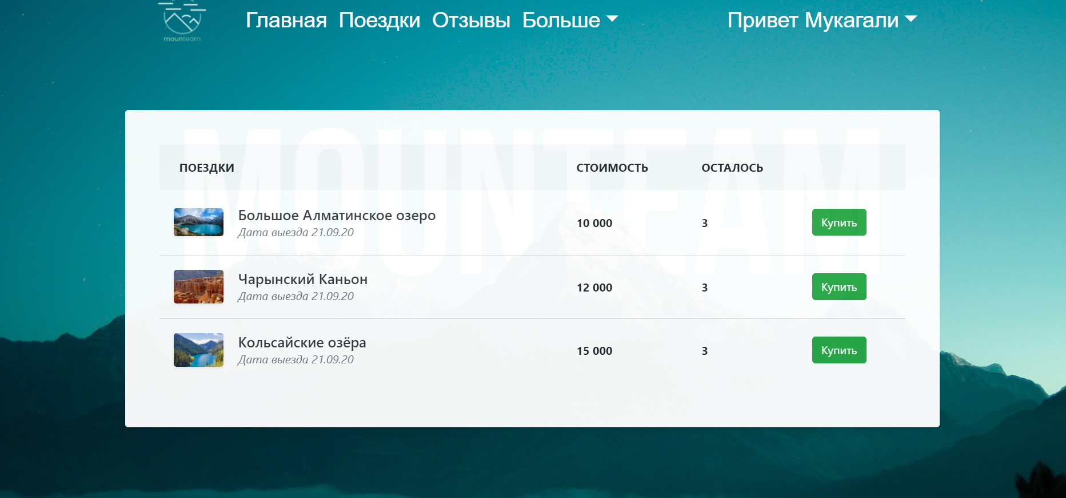

**let's add a new table to confirm the connection to the database. Fill in the name of the ticket, the price, the rest of the ticket, the information and choose which class category it belongs to.**

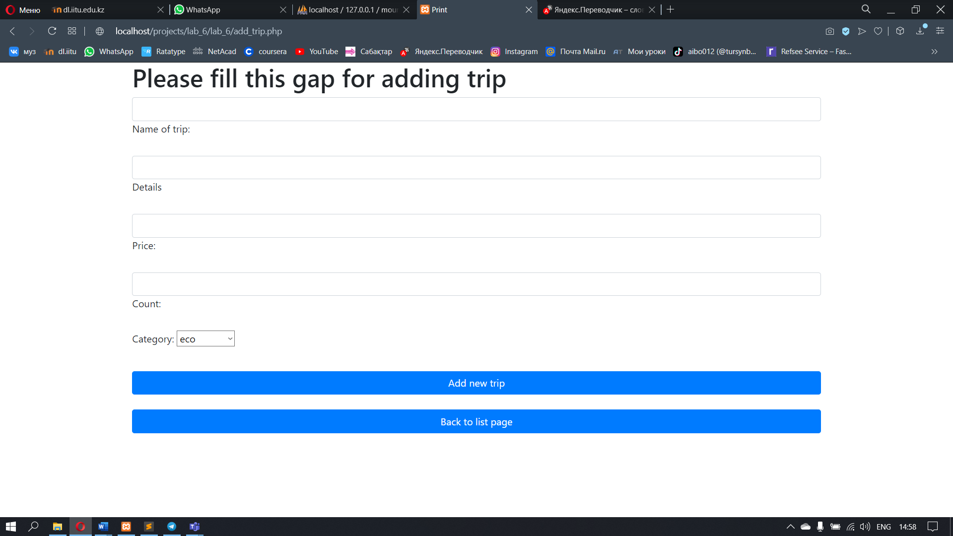

**As you have noticed, the database has changed and a new trip has been added.one thing we observe is that if we select a category in a table with a name, it will be stored in the database with an id.**

**Now let's change the information we added.Let's just lower the ticket price. the information changes instantly in the database.This is how quickly information is deleted.**

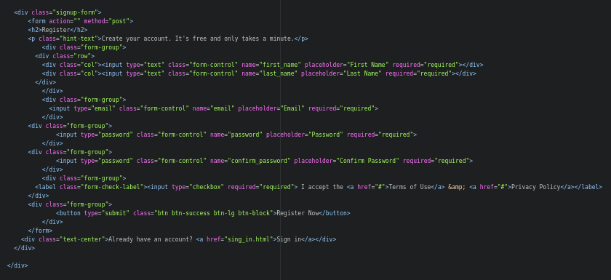 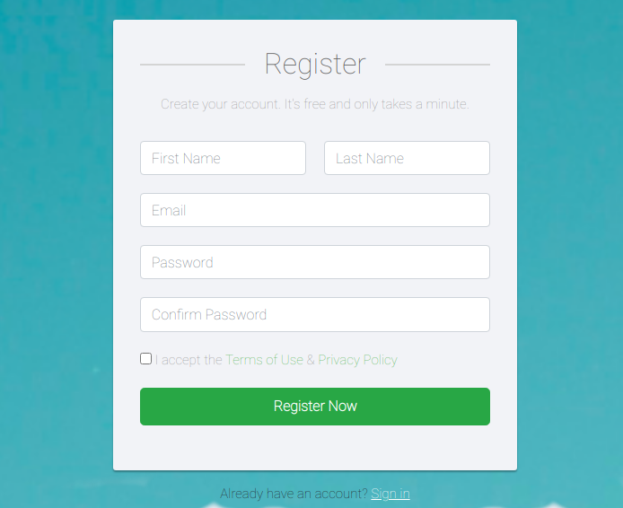

Conclusion …

Summing up the result, in conclusion, I would like to note that the Internet plan in the "travel agency" project gave us a huge skill, but also provided us with a focus and motivation to continue working with the largest programs. In this direction, I have learned a lot from the style of html,css,sql.js up to php-scripts in the very beginning, if I just researched Internet research, ordinary html and css seemed to us very difficult, but now, after a whole laboratory activity, if I previously worked with the basics of information also php-scripts, this is similar in the clicking of fingers, also all without exception given due to the plan that I aspired to make, also the direction of Internet research. I made a plan in absolute agreement with the terms of the course plan also believe that we all, without exception, this turned out, I formed a website travel agency, with an interesting unique design, linked it with the basis of information also purchased a website that I females wanted to observe also due to this their website came out unique also interesting also extremely met the conditions.

References …

1 Textbooks

Learning PHP, MySQL & JavaScript With jQuery, CSS & HTML5 (Robin Nixon)

[PHP and MySQL Web Development 5th Edition](https://dl.iitu.edu.kz/pluginfile.php/413401/mod_folder/content/0/PHP_and_MySQL_Web_Development_5th_Edition_-_2017.pdf?forcedownload=1)

2 Papers

3 Internet addresses/resources

[W3Schools HTML](https://www.w3schools.com/html/)

<https://html5book.ru/osnovy-css/#:~:text=CSS%20(Cascading%20Style%20Sheets)%20—,документам%20HTML%20и%20приложениям%20XML>).

<https://htmlacademy.ru/tutorial/php>

<https://getbootstrap.com/docs/5.0/getting-started/introduction/>

<https://devdocs.io/>

<https://tympanus.net/codrops/css_reference/>